4.3 Double Integrals in Polar Coordinates

Recall: The identities that link the polar coordinates of a point to the rectangular coordinates of the same point are , , and .

A polar rectangle is a region of the form . A picture of a polar rectangle is (the actual rectangle is outlined in green):

Motivating Question: In this section, our first concern will be trying to find a way to find the signed volume of a solid bounded by some function and a polar rectangle. Mathematically, we wish to compute where is a polar rectangle and is continuous.

We know that is the signed volume of the solid bounded by the surface determined by and the polar rectangle R. So, the idea to calculate the signed volume is to divide into m subintervals of the form each with width and to divide the interval into n subintervals of the form each with width .

Then the circles and the rays divide the polar rectangle into smaller polar rectangles. A picture of such a rectangle is shown below:

In actuality the above picture would have many more red lines and many more small polar rectangles.

In order to approximate we will add up the volume of prisms which have bases that are polar rectangles and heights given by the function . The idea is that our approximation will approach perfection as both m and n approach infinity.

To find the volume of such prisms we need to find a formula for the area of . We see that the area of is the difference of the area of two circle sectors. So, we have that .

We know we need to pick a sample point in to plug into in order to get our height. So, we let and . This means that our approximation becomes:

As we let m and n approach infinity this approximation approaches perfection (one would have to prove that this idea that we used for rectangles also holds for polar rectangles). So, if we let , we have that
.

We recognize the right most sum as a double integral! So, by Fubini’s theorem
The following result summarizes the above derivation.

Change to Polar Coordinates in a Double Integral Over a Polar Rectangle):
If is continuous on a polar rectangle R given by , where , then .

Example 1: Find the volume of the solid that is under the hemisphere given by and above the region bounded by and .
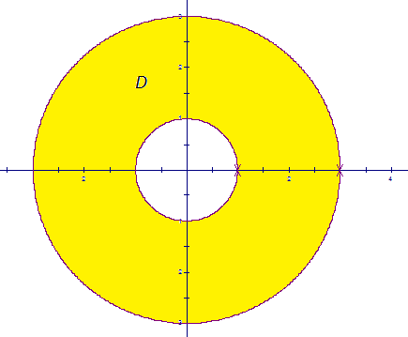
A picture of the region (call it D) is shown at the right.

We wish to find . This integral appears to be difficult in rectangular (since D is not a type 1 or a type 2 region). So, we try to convert this integral to polar.

We note that in polar .

So, we have that .

For the innermost integral we let , and we note that and . So,

Example 2: Setup, but do not evaluate, an iterated integral which represents the volume of the solid bounded by the plane and the surface in the first octant.
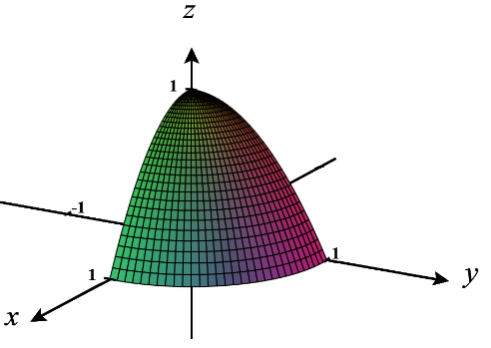
Note that intersects the xy-plane when . When this happens, we see that , meaning the intersection is a circle of radius 1. Therefore, we recognize that we are integrating over the region

Therefore, .
One is able to generalize the above result, (with a method similar to how we generalized from rectangles to type 1 and type 2 regions in 4.2) and obtain the following theorem. If it is the case that r can be bounded by two functions rather than two constants we can update the pervious formula to the following.

Theorem (Change to Polar Coordinates in a Double Integral Over a Non-Rectangular Polar Region):
If is continuous on a polar region of the form , then .

Note: A subtle point here is that two distinct points in D should not be in the same spot on the plane, if we are thinking of the double integral as giving a signed volume.

Note: would yield the area of the polar region D.

Note: It is possible to deduce the formula learned for polar integrals in calculus II from this theorem! Think about how this would be done.

Example 3: Use a double integral to find the area of one loop of the rose given by .

A picture of the rose (with one shaded leaf) is:
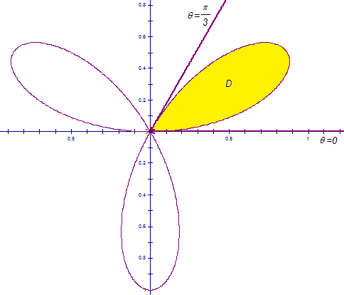
We notice that the first leaf is traced as varies from 0 to pi over 3. Moreover, r stays nonnegative as the first leaf is traced. This means that our region of integration is .
So, the area is

The next example is one of my most favorite math problems of all time. Those of you who may have taken me for Calculus II are aware of the awesomeness that is this next problem!
Example 4: Evaluate the following improper integral: .

This particular improper integral is quite difficult to evaluate because does not have an antiderivative which can be represented with elementary functions. However, in Calculus II we can prove that converges (we just have no idea what it converges to).

So, suppose that we let . Then,
We note that the region of integration is the entire first quadrant.
In polar, we can represent the first quadrant as the set .

Now, we know that
Thus, we have that , and we know that !

